**Tutorial 36: Router Links**

In this tutorial we will focus on how to use router links to navigate between pages. Normally anchor tags would be used to switch between pages however, Vue only has 1 HTML page since it is used to build a single page application, therefore we are navigating and changing components rather than pages. This means that there is no load time since the network request has already been made from the server having provided the files to load on the browser already.

The syntax for router links look like below:



The to=”” represents the path of the next page to navigate to. /about means that the user wants to go to the about page.

Another way to redirect is to include a data bind to the to attribute and pass an object where the key is name and pass in the name of the component we want to navigate to. The advantage of doing it this way is if the user changes the page path then you do not have to go to every page and update the path.

Look at line 4.



In the index.js file inside the router folder, the name of the component can be found in the array of objects containing the details related to navigating through different components. The about page has a path of /about, a name called About and the imported component called About. Look between line 5 and 16. The :to {name: ‘About’} will match with the name provided in line 13.

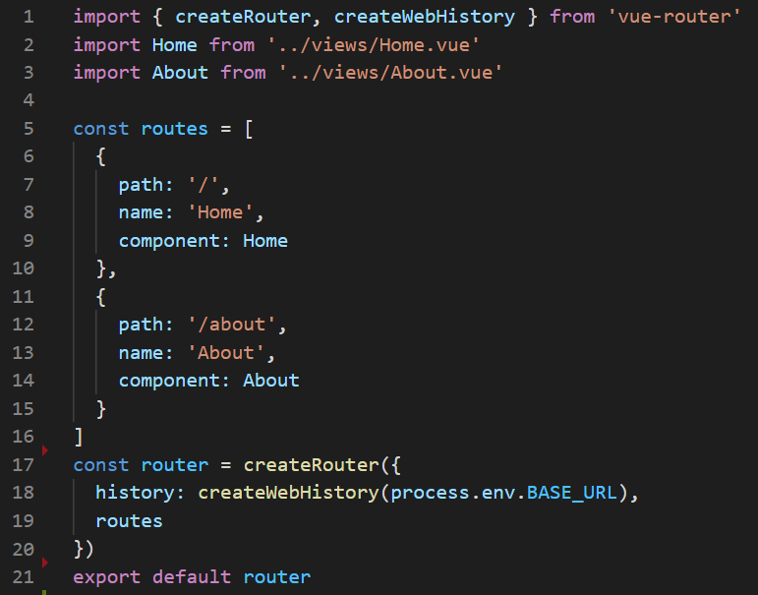

Make sure **Tutorial 35** is complete to be able to move on to this tutorial or clone the [vue3-firebase-course](https://github.com/younggrasshopperza/vue3-firebase-course) repository and go to branch called **Tutorial-35** and navigate to the young-grasshopper-jobs folder.

**Step 1:** We will be setting up the basic structure of the application. Go to the src folder and then the components folder and delete the HelloWorld component.

Inside App.vue file remove the HelloWorld component in the template and the script and remove the image tag in the template.

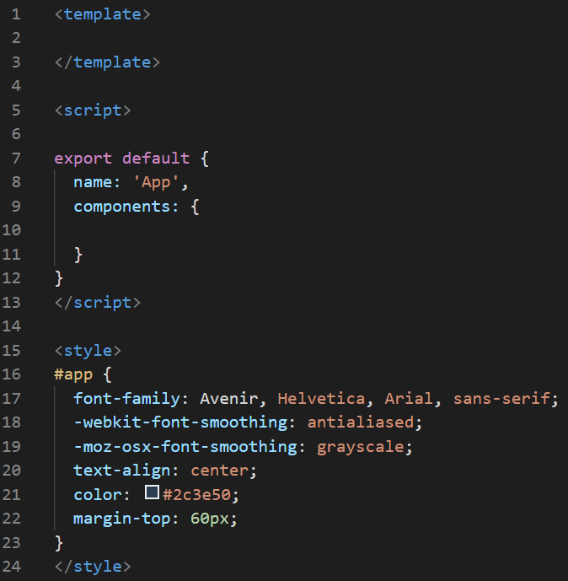

**Step 2:** In the Home.vue file, delete the HelloWorld component inside the template and inside the script by the component property. Inside the template, inside the div tag with a class called home, create an h1 tag with the text Home Page and a p tag and type lorem100 and select the default option or press tab.

Look at the example below (**Line 4**):

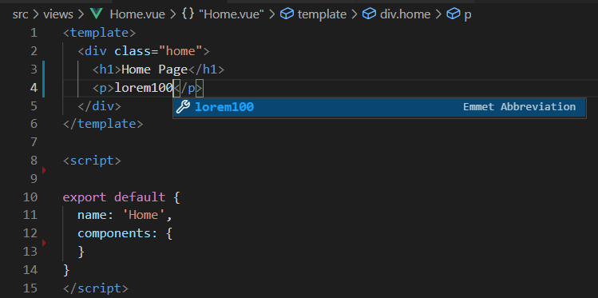

Duplicate the p tag and paste the same content below.

Look at the example below (**Between Line 4 and line 5**):

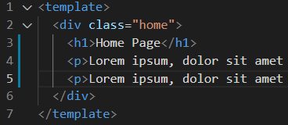

**Step 3:** In the About.vue file, change the text of the h1 tag to say “About Page” and create 2 p tags with lorem ipsum text.

Look at the example below (**Between Line 1 and line 7**):

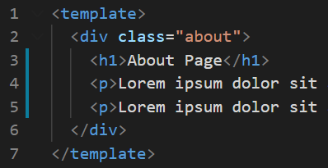

**Step 4:** In the App.vue file, add the following css code in the styles tag:

#nav a {

  font-weight: bold;

  color: #2c3e50;

  text-decoration: none;

  padding: 10px;

  border-radius: 4px;

}

#nav a.router-link-exact-active {

  color: white;

  background: crimson;

}

By default when the router is active on the link it has a class called router-link-exact-active attached to the link on the navbar.

**Output:**

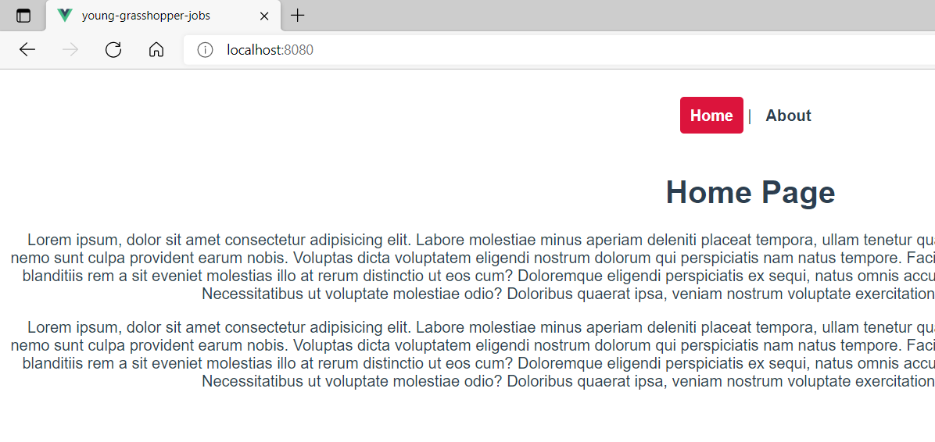

**Output:**

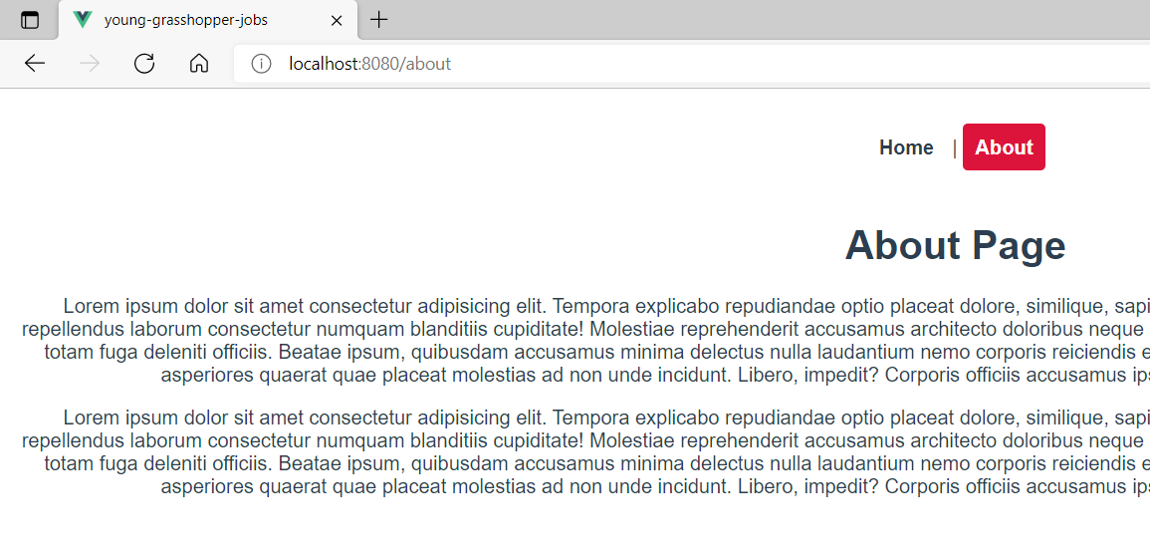

**You can view the code snippets from the** [**vue3-firebase-course**](https://github.com/younggrasshopperza/vue3-firebase-course) **repository under the Tutorial-36 branch**.